

Scouts Australia
Victorian Branch
Heany Park Scout Group
Makeham Ave, off Golding Ave
Rowville Vic 3178
A.B.N. 39 662 387 026
Postal Address
PO Box 2789
Rowville Vic 3178
Internet: www.heanyparkscouts.com.au
Email: gl.heany-park@vicscouts.asn.au

Heany Park Scout Group Climbing Wall Instructions
General Requirements:-
- Climbing Wall (CW) to be set up on firm, even and level surface.
- Maximum of 2 climbers at any one time.
- Minimum of 2 supervising personnel while the CW is in use.
- Personnel involved in assembly, supervision & disassembly must be aware of the requirements of the CW.
- Ensure the CW is assembled using all components including horizontal beams, bolts (both horizontal & vertical), rear ballast plate & ballast
- Minimum of 750kg ballast or equally rated tie-down straps to an anchor point(s) must be in position before use. A vehicle can be parked over the ballast plate.
- Do use CW when raining, stormy or in wet conditions. Cover CW with tarp when raining & overnight if set up outdoors.
- Cease use of CW where wind gusts may exceed 20km. Consider disassembling wall or adding additional tie downs to secure CW in the event of high winds.
- Climber’s feet should not exceed 1800mm from ground level.
- Safety mats must be in position before use.

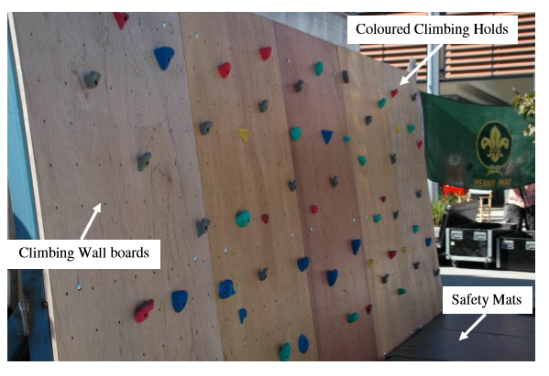

IN FELLOW SHIP WE LIVE

General Information: -
- Assembled CW is 2.4m high x 6m wide
- Climbing boards & steel uprights are numbered & are position specific
- The steel uprights & rear ballast plates are heavy & require a minimum of 2 adults to handle.
- The climbing boards are 2.4m long & 1.2m wide & require a minimum of 2 people to handle.
- It is recommended that a minimum of 4 adults assessable & disassemble the CW.

Components & Tools
• 6 x Steel Uprights
• 5 x Climbing Boards with threaded holes for climbing holds
• 3 x Horizontal 2-piece Beam Sets (an upper, mid & lower set)
• Assorted coloured climbing holds
• Allen key fasteners to secure Climbing Holds to Climbing Boards – Note there are long, med & short fasteners to suits the various thicknesses of the coloured Climbing Holds
• 2 x “T” piece Allen Key tools
• Long bolts inserted vertically to secure Horizontal Beams to Steel Uprights
• Short bolts with pin holes to attach Climbing Boards to Horizontal Beams
• Hammer to assist with inserting & removing bolts pins – do not use excessive forced. Ensure area is level to assist with alignment of holes.

Assembly (Reverse order for Disassembly)
- Position Steel Uprights in numerical order. (#1 is on LHS when facing front of CW)
- Use personnel to hold uprights in position & take care that they don’t fall over
- Place the mid-level Horizontal Beam into position & insert vertical pin (long bolts)
- Continue placing Steel Uprights & Horizontal Beams till assembled. Ensure all vertical pins have been inserted & tapped in with hammer as necessary.
- Install Steel Ballast Plate (2-piece) at rear of Steel Uprights – holes in plates to secure in position via upright bolts on Steel Uprights
- Place Climbing Boards in numerical order as shown on rear of boards.
- Secure Climbing Boards with Horizontal Pins (short bolts). Fit over-sized nut & secure with steel nail into hole in bolt. Ensure Horizontal Pins are installed & secured.
- Install Climbing Holds using Allen Key fasteners – Note 3 lengths & must use correct size fastener to match thickness of Climbing Holds. Secure fasteners firmly but do not over tighten
- Place Safety Mats in position & ensure are snug with no gaps

IN FELLOW SHIP WE LIVE
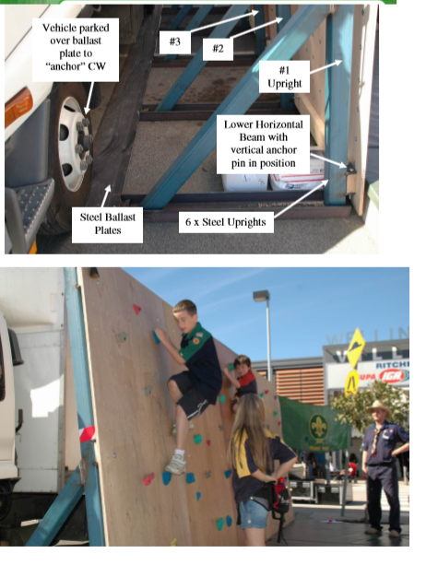

IN FELLOW SHIP WE LIVE

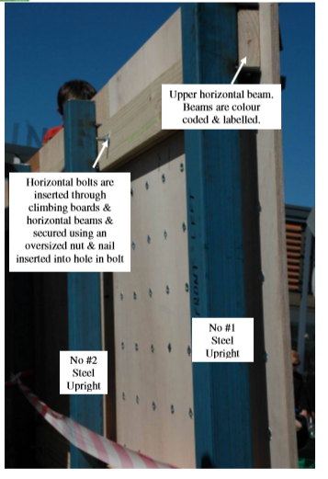
IN FELLOW SHIP WE LIVE

