
Apparel Order Form


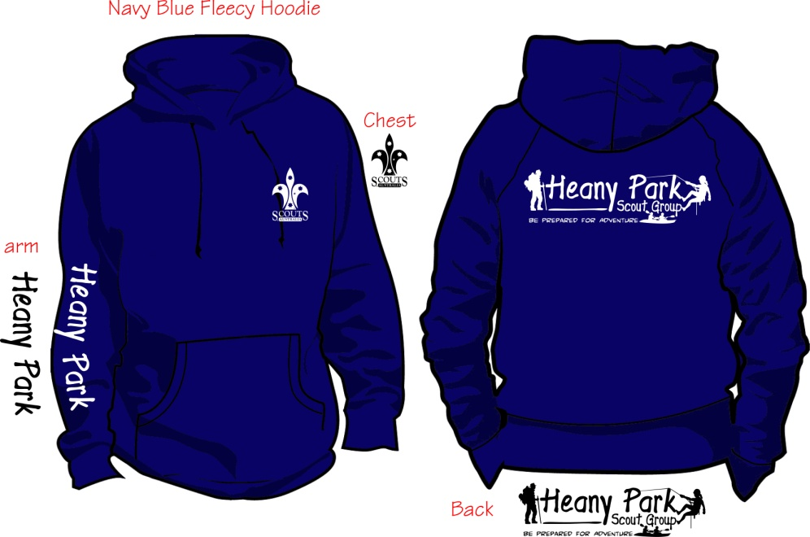

Please bring $ and form to your try on session at the hall
Contact Karen weskaz@bigpond.com – 0418511066
Tracey traceyteunissen@gmail.com - 0411265526
All HPSG Members will be given their first hat/flatcap for FREE
Replacement Hats $10 New Windcheaters $35 Second Hand $5
Name of Member:
Section:
Parent Name:
Mobile: Email:
No Hats Ordered:
No Windcheaters Ordered: Size:
Total Paid:
Date Issued to Member:
We would recommend a try on session for windcheater sizes.
Child XS; Child Small; Child Medium; Child Large; Child XL
Adult XS; Adult Small; Adult Medium; Adult Large ; Adult XL; Adult XXL; Adult XXXL (special order)
*Venturers / Leaders pls contact Michelle Pagonis to organise name on rear of windcheater.

