

**Apparel Order Form**

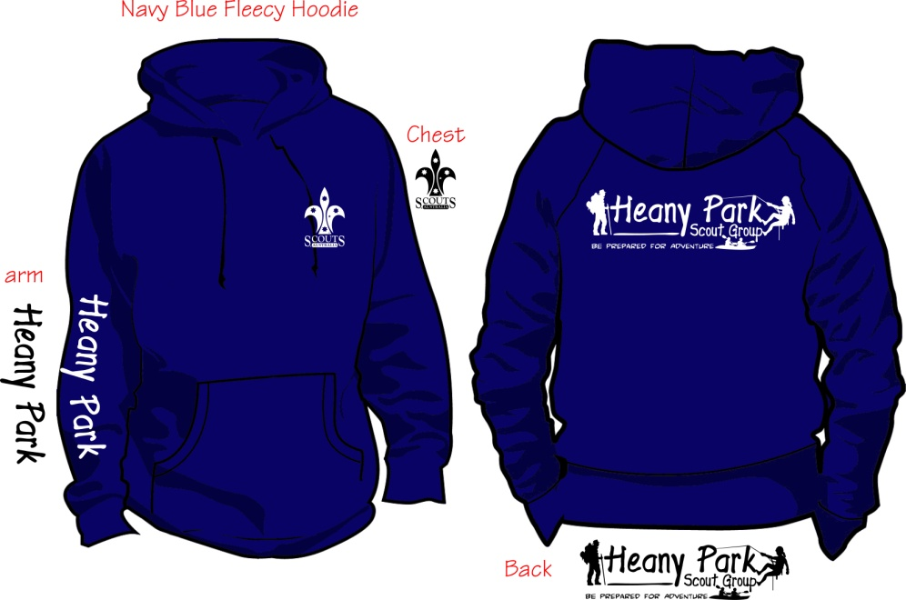

**Please bring $ and form to your try on session at the hall**  
Contact Karen [weskaz@bigpond.com](mailto:weskaz@bigpond.com) – 0418511066   
Tracey [traceyteunissen@gmail.com](mailto:traceyteunissen@gmail.com) - 0411265526

All HPSG Members will be given their first hat/flatcap for FREE

Replacement Hats $10 New Windcheaters $35 Second Hand $5

Name of Member:

Section:

Parent Name:

Mobile: Email:

No Hats Ordered:

No Windcheaters Ordered: Size:

Total Paid:

Date Issued to Member:

We would recommend a try on session for windcheater sizes.  
Child XS; Child Small; Child Medium; Child Large; Child XL  
Adult XS; Adult Small; Adult Medium; Adult Large ; Adult XL; Adult XXL; Adult XXXL (special order)  
*\*Venturers / Leaders pls contact Michelle Pagonis to organise name on rear of windcheater.*